Strictly Ballroom

Maria de Dios
26/11/15

INTRODUCTION
Strictly Ballroom is a film from Australia. The film was created in 1992. It's a romantic comedy film. The director of Strictly Ballroom is Baz Luhrmann. This film was the first that Luhrmann created and the first of the triology "The Red Curtain Triology" the two others movies of this triology was Romero and Juliet (1996), and Moulin Rouge (2001).
Strictly it's based in a play, that was released in 1984 for Luhrmann and others students of the National Institude of Dramatic Arts from Sidney.
It tells the story of Scott a male dancer who wants to create its own form of dance because he wants to win the competition whit her couple, Fran, she enters the "pasodoble" and they reach win the competition.
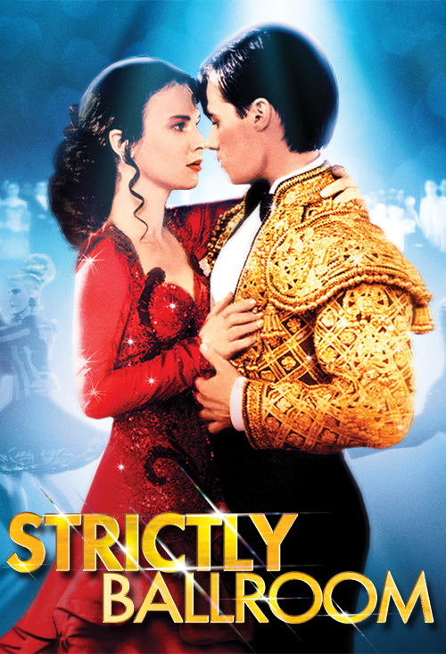

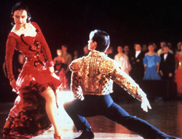

THE WORLD OF THE FILM

There are two worlds shown in this film and both are opposed to each other:

The ballroom dancing world. This film shows how glamour the outward appearances of the Anglo-Australian inside the ballroom, with the colourful dresses that match with the shoes, as well as their hairdos. All of the dancers try their best to look stunning in front of the judges and the audience, to win the championship. This world takes place in an interior location, which somehow represents the rigidity that occurs in it. The Dance Federation, who holds the ultimate power in this place, embraces the regulations and requires all of the dancers to follow those regulations, strictly. It can be linked as well to one of the social influence namely obedience, where actions are performed in order to respond to direct orders which usually from the person with the high status or authority.

Fran’s Spanish family world. This family came to Australia as immigrants and they live in the suburbs of Sydney, which the house is exactly beside the railway tracks. They own a small and shabby bar called Toledo Milk Bar. All of the people in this family are just ordinary people who do not have any authority and power to control other people. Therefore, instead of emphasis on wealth, they more concern to maintain their culture, such as the Paso Doble dance. The exterior location of Fran’s house portrays relief and freedom atmosphere for the people who come to this house. The huge different between these two worlds is the way they dance. When the Australian dancers always dance to fulfil their desire to win the competition, this Spanish family has their own perception of dancing. They always dance from their heart, so they really relish every steps of the dance with passion. This Spanish family actually shows the real meaning behind a dance, that there are freedom, expression, and emotion within every movement that should be enjoyed by the dancer.

HERO, HEROINE, VILLAIN

-Hero
Scott is the principal character in the film. He is positioned as the hero
Scott is a very talented and dedicated dancer. He has been dancing since he was six years old, working to win the Pan-Pacific Grand Prix Dancing Championship. However, his rebellious side cannot be contained and it is his passion for dancing that leads him to try his own steps. Such passion and dedication is admirable.
-Heroine
Like Scott, Fran is positioned as the heroine in the film.
Fran is at first nervous and clumsy as she is still a beginner. Nevertheless, as she learns dancing from Scott, her confidence builds, her moves become graceful and full of life. The audience, as well as Scott, get to witness the bloom of a talented dancer with Spanish blood coursing through her veins.

-Villain
Barry Fife is the typical villain of the story. He is a large frightening old man, who appears to be very unapproachable. He is the President of the Australian Dace Federation. Barry is the one who strictly put the regulation of prohibition of the new steps on the dance floor. It can be seen from his role, that he wants something always function according to his rule.

