Roasted vegetable lasagne

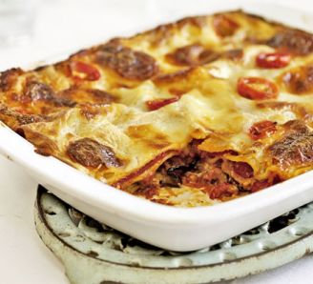

Ingredients
- 3 red peppers
- 2 aubergines
- 8 tbsp olive oil, plus a little for greasing
- ½ quantity tomato sauce (see below)
- 300g fresh pack lasagne sheets
- ½ quantity white sauce (see below)
- 125g ball mozzarella
- handful cherry tomatoes, halved
Method
- Heat oven to 200C/fan 180C/gas 6. Deseed the peppers, halve, then cut into large chunks. Trim ends off aubergines, then cut into slices about ½cm thick. Lightly grease 2 large baking trays, then place peppers and aubergines on top. Toss with the olive oil, season well, then roast for 25 mins until lightly browned.
- Reduce oven to 180C/fan 160C/gas 4. Lightly oil an ovenproof serving dish (30 x 20cm). Arrange a layer of the vegetables on the bottom, then pour over a third of the tomato sauce. Top with a layer of lasagne, then drizzle over a quarter of the white sauce. Repeat until you have 3 layers of pasta.
- To finish, spoon remaining white sauce over the pasta, making sure the whole surface is covered. Scatter mozzarella over the top with the tomatoes. Bake for 45 mins until bubbling and golden.

