Patrick Pearse
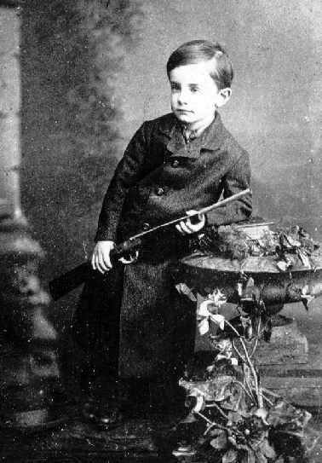
Patrick Pearse life
Born in Dublin on Great Brunswick Street (now Pearse Street), he was educated by the Christian Brothers at Westland Row, before taking a scholarship to the Royal University (University College Dublin) to study law.
In 1898 Pearse became a member of the Executive Committee of the Gaelic League. He graduated from the Royal University in 1901 with a degree in Arts and Law. He was later called to the bar. From his early school days he was deeply interested in Irish language and culture. He joined the Gaelic League in 1895 and became editor of its paper, An Claidheamh Soluis (Sword of light). He lectured in Irish at UCD.
To advance his ideal of a free and Gaelic Ireland Pearse set up a bilingual school for boys, St Enda’s, at Cullenswood House, Ranelagh, Dublin, in September 1908. He later moved the school to a larger location at Rathfarnham in 1910. Initially, Pearse was a supporter of Home Rule but his outlook on Irish freedom was to become more radical and when the Irish Volunteers formed in November 1913, he was elected a member of the provisional committee and later the Director of Organisation. In July 1914, Pearse was involved in the smuggling of weapons and ammunition through Howth Co Dublin which were stored at St Enda’s.
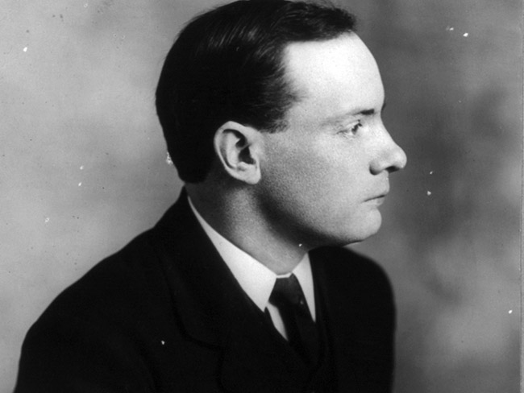
As his views became more militant, Pearse’s graveside oration at the funeral of Fenian leader O’Donovan Rossa in 1915 ended with the much quoted words “Ireland unfree shall never be at peace”.
One of the founder members of the Irish Volunteers, and the author of the Proclamation of Independence, Pearse was present in the GPO during the Rising, and was Commander in Chief of the Irish forces. At 3.30pm on April 29, 1916 he surrendered unconditionally on behalf of the Volunteers to Brigadier-General W. H. M. Lowe in Parnell Street, to prevent further loss of civilian life. Following a court martial at Richmond Barracks for his part in the Easter Rising, Pearse exclaimed: “You cannot conquer Ireland. You cannot extinguish the Irish passion of freedom. If our deed has not been sufficient to win freedom, then our children will win it by a better deed.”
He was executed holding a crucifix on May 3, 1916 at Kilmainham, and was buried in quick lime at Arbour Hill. He was unmarried. Pearse’s brother William was also executed. In Ballymun, the Patrick Pearse Tower was named after him as was Pearse Street, Dublin.
Patrick’s Pearse poems
Pearse wrote stories and poems in both Irish and English. His best-known English poems include "The Mother" and "The Fool"

The Mother
I do not grudge them: Lord, I do not grudge
My two strong sons that I have seen go out
To break their strength and die, they and a few,
In bloody protest for a glorious thing,
They shall be spoken of among their people,
The generations shall remember them,
And call them blessed;
But I will speak their names to my own heart
In the long nights;
The little names that were familiar once
Round my dead hearth.
Lord, thou art hard on mothers:
We suffer in their coming and their going;
And tho' I grudge them not, I weary, weary
Of the long sorrow - And yet I have my joy:
My sons were faithful, and they fought.

Pearse wrote this poem before he died, and he wrote like if he was her mother he shows a lot of empaty in the poem also this poem shows the emotions aroused by the Rising and evokes the shared experiences that bind nation and family together.
It’s a poem that I like it but I think it’s very sad

The Fool
Since the wise men have not spoken, I speak that am only a fool;
A fool that hath loved his folly,
Yea, more than the wise men their books or their counting houses or their quiet homes,
Or their fame in men's mouths;
A fool that in all his days hath done never a prudent thing,
Never hath counted the cost, nor recked if another reaped
The fruit of his mighty sowing, content to scatter the seed;
A fool that is unrepentant, and that soon at the end of all
Shall laugh in his lonely heart as the ripe ears fall to the reaping-hooks
And the poor are filled that were empty,
Tho' he go hungry.
I have squandered the splendid years that the Lord God gave to my youth
In attempting impossible things, deeming them alone worth the toil.

Was it folly or grace? Not men shall judge me, but God.
I have squandered the splendid years:
Lord, if I had the years I would squander them over again,
Aye, fling them from me !
For this I have heard in my heart, that a man shall scatter, not hoard,
Shall do the deed of to-day, nor take thought of to-morrow's teen,
Shall not bargain or huxter with God ; or was it a jest of Christ's
And is this my sin before men, to have taken Him at His word?
The lawyers have sat in council, the men with the keen, long faces,
And said, `This man is a fool,' and others have said, `He blasphemeth;'
And the wise have pitied the fool that hath striven to give a life
In the world of time and space among the bulks of actual things,
To a dream that was dreamed in the heart, and that only the heart could hold.

O wise men, riddle me this: what if the dream come true?
What if the dream come true? and if millions unborn shall dwell
In the house that I shaped in my heart, the noble house of my thought?
Lord, I have staked my soul, I have staked the lives of my kin
On the truth of Thy dreadful word. Do not remember my failures,
But remember this my faith
And so I speak.
Yea, ere my hot youth pass, I speak to my people and say:
Ye shall be foolish as I; ye shall scatter, not save;
Ye shall venture your all, lest ye lose what is more than all;
Ye shall call for a miracle, taking Christ at His word.
And for this I will answer, O people, answer here and hereafter,
O people that I have loved, shall we not answer together?

